Evaluating the Security Configurations for Windows Server 2012

Student’s Name

Institutional Affiliation

Date

Evaluating the Security Configurations for Windows Server 2012
The vendor documentation of the security update for the for Windows Server 2012 according to the Nessus Home vulnerability scan is: SYSTEM\CurrentControlSet\Control\Session Manager\Memory Management\FeatureSettingsOverride, and SYSTEM\CurrentControlSet\Control\Session Manager\Memory Management\FeatureSettingsOverrideMask. In the scan, the scan indicates that 0 & 3 now tenable need to be blank and the Nessus scan seems to be flagging them. When the Microsoft.NET framework fails to verify and validate the input properly, there seems to be remote code execution vulnerability. According to the Nessus scan, the windows host is missing a security update 4471326 and the cumulative 4471330. These particular updates address how the windows host handles items in the memory.
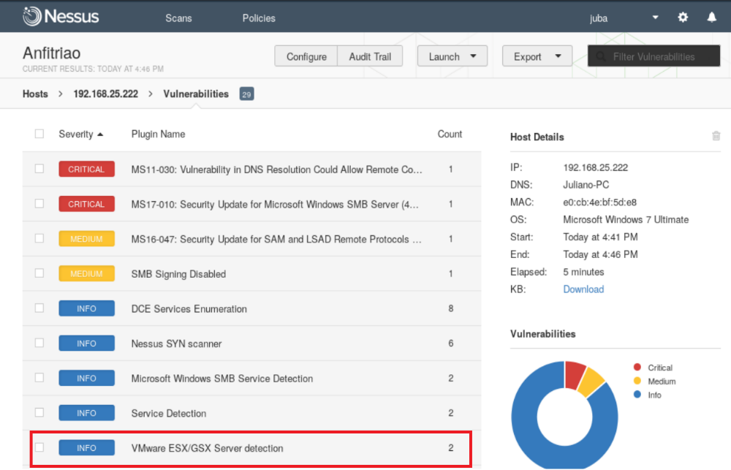
Figure 1:
In the IP host 192.168.25.222 (Figure 1), identified as being from Windows OS 2008, the vulnerability named MS11-030, identified by the code CVE-2011- 0657, was detected (Arambatzi et al 2016). This vulnerability could allow remote code execution through a DNS resolution failure if an attacker gains access to the network and creates a custom program to send LLMNR broadcast queries specially created for this target system (Arambatzi et al 2016). The Openvas tool follows the same characteristics as Nessus, but under an OpenSource license. In addition to also identifying the criticality of the vulnerability, host name on the network and the service port running, among some of the different characteristics in relation to Nessus, it has a QoD (quality of detection) column, which points in percentage the probability vulnerability actually exists on the target (Arambatzi et al 2016). Below are shown in Figures 1 and 2 the two main results of the Scanner performed by Openvas, with the name of the vulnerabilities, criticality and port of the identified service.
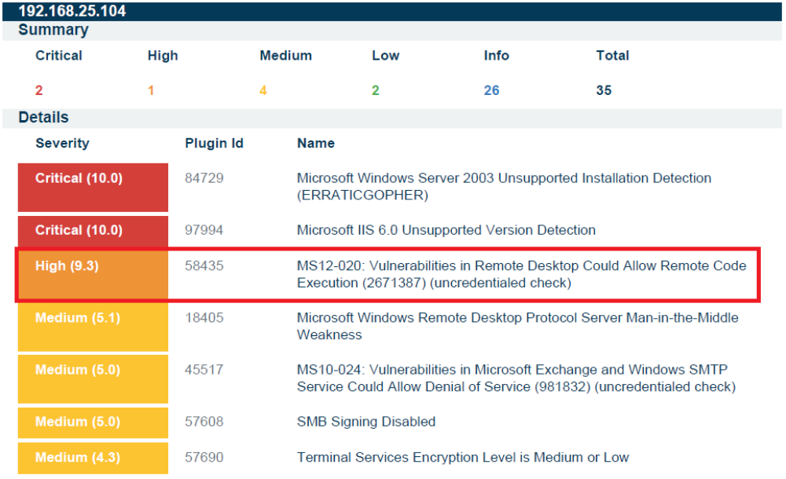
Figure 2:
During each Nmap execution, data analyzes were performed, looking for information that would help in identifying vulnerabilities in the environments (Arambatzi et al 2016). In the first scans, it was possible to identify with evidence that the attacker was inside a network environment with virtual machines. This identification occurred during the action of Nmap when performing a ping scan, but with the port scan function disabled through the -sn parameter, so as not to trigger the network security countermeasures (Arambatzi et al 2016). In this same action, the Verbose mode was used, with the –v parameter, where the actions shown by Nmap during the scan are shown on the screen. As shown in Figure 2, this action brought as a response, among other information from the host, the MAC Address identification of each target, even if it does not have any published services.
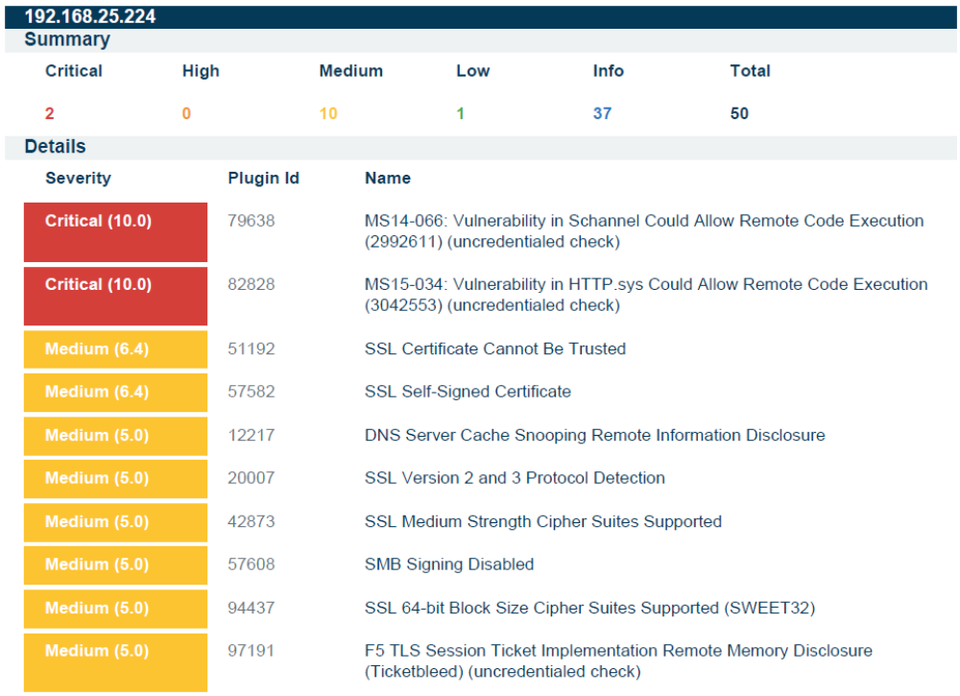
Figure 3:
With this information, the tool itself made a query to its database, returning with the identification of the manufacturer responsible for using that MAC Address, since this control is done through the first bytes of identification of each address that is divided for each manufacturer of drivers, network, whether physical or virtual (Arambatzi et al 2016). As in this case the host was hosted on a virtual environment, the virtualizing platform was responsible for providing a virtual MAC Address, so that the operating system can perform network actions such as requesting IP to the DHCP server or sending data packets to other hosts with their identification for the correct switching carried out by Switche that controls the actions of the hosts' packages through the ARP table (Arambatzi et al 2016).
In this way it is possible to save and organize the actions and data collected, in addition to assisting in the search for vulnerabilities, as well as exploiting specific scripts to perform each attack, according to the services of the hosts identified in the scans, as well as details such as Host OS, installation package, services used.

References
Arambatzis, T., Lazaridis, I., & Pouros, S. (2016). Modern Windows Server Operating Systems Vulnerabilities. In The Third International Conference on Computer Science, Computer Engineering, and Social Media (CSCESM2016) (p. 2-9).
Kushe, R. (2017). COMPARATIVE STUDY OF VULNERABILITY SCANNING TOOLS: NESSUS vs RETINA. Security & Future, 1(2), 69-71.

